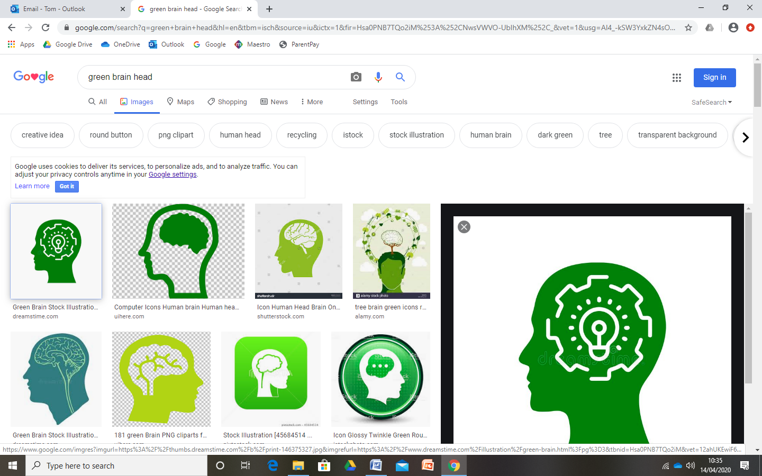

**Heart**The key values to let our light shine are:

* Self Control and The Rule of Law

**Head**This is the knowledge we will gain this half term. For example:

* Who helps us in our community?
* How can I be a person who helps others?
* How have different occupations changed

over time?

**Hand**These are the skills we will learn this half term. For example:

* Listening to others as they talk/explain
* Questioning – asking questions

to develop our own

understanding

**Ladybirds EYFS  
Journey of Discovery Spring 1**

**People Who Help Us**



**Literacy**

* Reading non-fiction books about People Who Help Us
* Using our phonics to label images, write captions to pictures and create posters
* Phonics – learn digraphs using

our school phonics resource.

**Maths**

* Count beyond 10 and subitise to 6
* Solving real life number problems
* Use positional, directional and

sequential language

* Repeating patterns – spot the mistake!

**Where 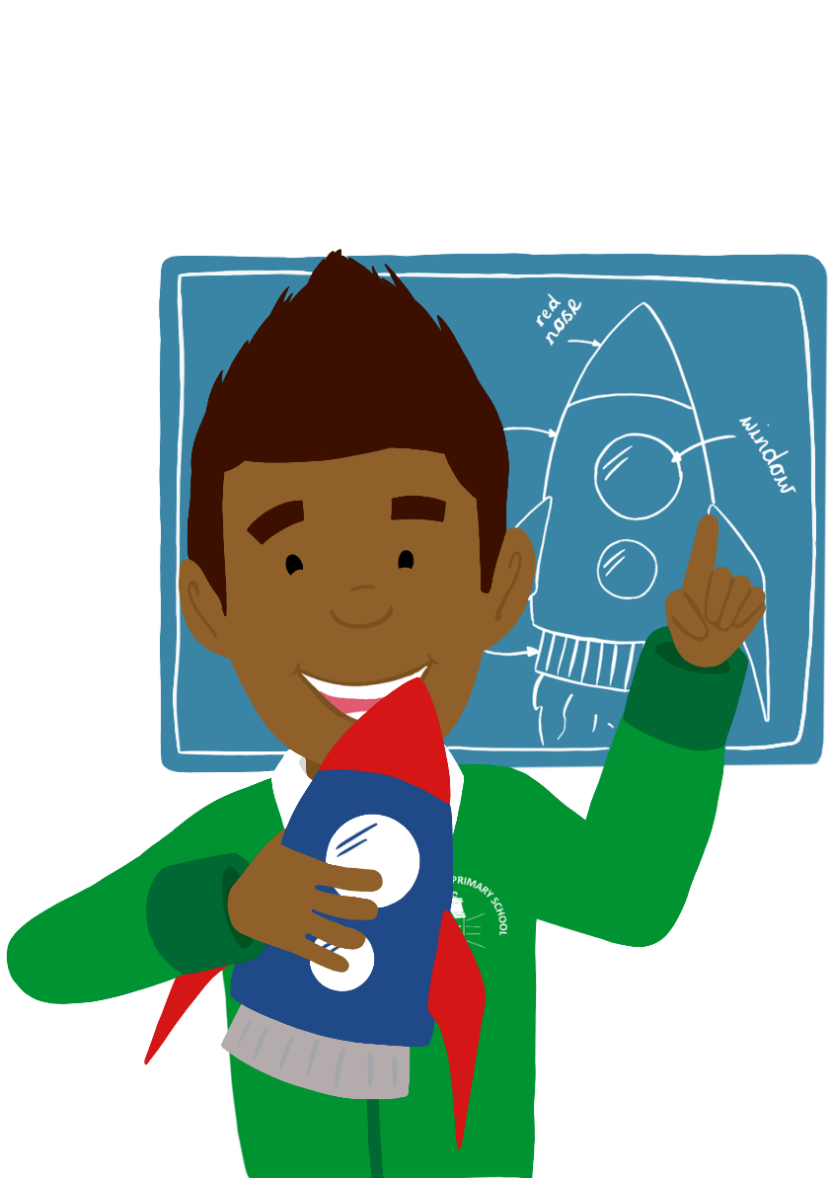 will we be visiting this half term?**

National S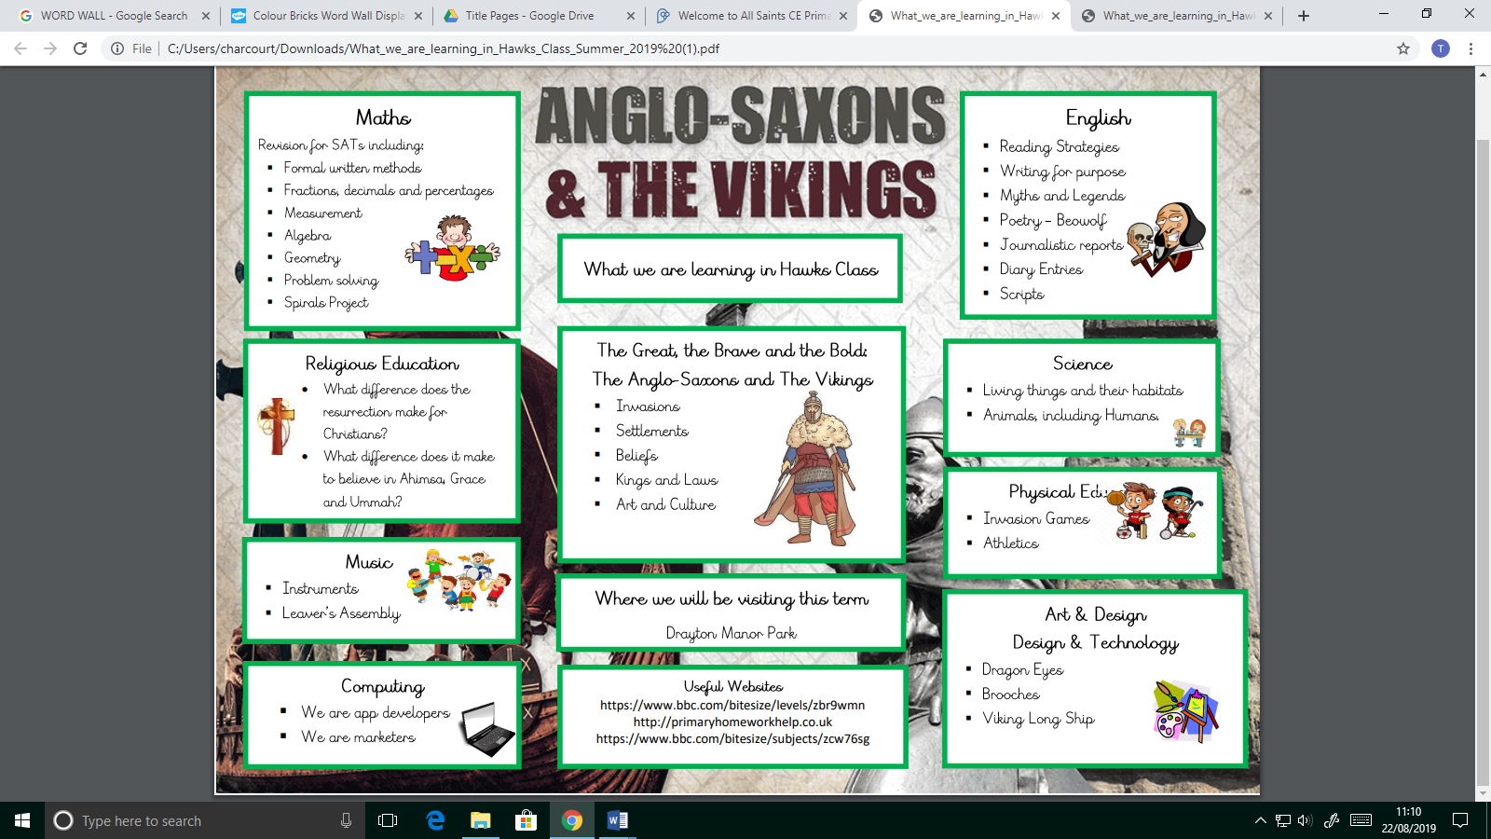pace Centre

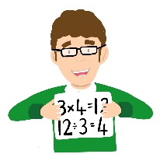

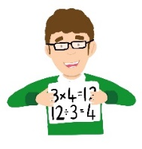

**Religious Education**

* Why is the word God so important to

Christians?

**Understanding the World**

* Learning about different occupations and how they have changed over time – past/present
* Developing an understanding of the differences between people
* Exploring the properties of different

objects

* Exploring different forces –

gravity/friction

**Personal, Social and Emotional Development**

* Developing our sense of self – how can we contribute to our community and help others?
* Collaborate with others to

achieve a goal

* Develop perseverance through

completing Emergency

Service challenges

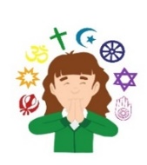

**Communication and Language**

* Learning new vocabulary about the Emergency

Services and other People Who Help Us

* Asking questions to develop our own

understanding

**Expressive Arts and Design**

* People Who Help Us Role Play area and small world play
* Creating collages
* Listening to different songs/pieces of music

and expressing our feelings

* Singing nursery rhymes and using

Instruments to make music

**Spark day**

* Visits from People Who Help Us in our community – local PCSOs, Fire Fighters, Crossing Patrol, Vet etc.

**Physical Development**

* Gymnastics in PE
* Getting dressed and

undressed independently.

* Moving with rhythm and

to music

* Practicing handwriting in

phonics

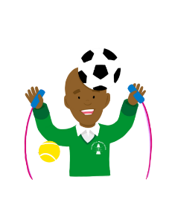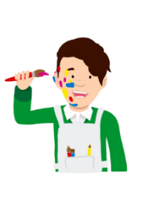

**Book List**

What The Ladybird Heard Burglar Bill

The Jolly Postman Happy Families Stories

Emergency Services non-fiction texts.